Migration and Women in the African Context

June 06 – 0 8, 2017
Dimesse Retreat Centre Karen-Nairobi

“A to Z” LOGISTICS INFORMATION FOR PARTICIPANTS
VENUE

The conference will take place at Dimesse Retreat Centre, Karen- off Lang’ata Road – Nairobi

Contacts :
Emeka Obiezu, emyxris@gmail.com
Joan Burke, burkejfsnd@aol.com
Robert Dueweke, rdueweke@gmail.com
Sr. Helen (Dimesse sisters) dimesse.retreatcentre@gmail.com

ACCOMMODATION

All participants will make arrangement for their own accommodation and board. However, accommodation is available at the Dimesse Centre, the venue of the conference @ 3000 KSH per night (full bed and board). Contact the management at dimesse.retreatcentre@gmail.com. 0724-939-871 or 0719-216-114

ACCESS TO INTERNET
There is free internet access at the conference venue (You will receive the password at registration)
AIR TRAVEL ARRIVAL AND IMMIGRATION REGULATIONS
Arrivals: Preferred air arrivals to the conference should be through the Jomo Kenyatta International Airport Nairobi. Arrangements are in place to pick up can be arranged; otherwise use uber or airport taxi services upon arrival.
Most non-citizens of Kenya and East Africa need a visa to enter Nairobi. Visa can be obtained at the port of entry at the cost of $50 or Euro40. Sometimes the queue may be long. Also you need to have yellow card to show that you have been vaccinated against yellow fever. Make sure you obtain this before you begin your journey to avoid denial of entry at Nairobi airport.

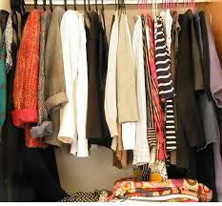 | CLOTHING  In Nairobi the month of June, temperatures range from 67°F/19°C to 80°F/22°C. The Dimesse Centre has air conditioning, but it is not a centralized cooling system, So you can choose the temperature that meets your need
CURRENCY

Presently, US dollar to Kenyan Shilling is approximately: $1 = 100KSH and €1= 115KS. You change at the airport, the bank or bureau de change in the city center or malls.
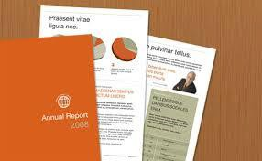 | CONFERENCE DOCUMENTS  All necessary documents will be provided at registration. This will include the folders, writing papers and pens. Some useful materials relevant to the conference theme will also be available
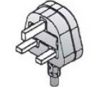 | ELECTRICITY AND PLUG INFORMATION  Electricity in Nairobi is supplied at 220-240 Volts AC, 50 Hz (US is 110-120 volts).  Electrical sockets (outlets) in Nairobi British BS-1363. If your appliance’s plug doesn’t match the shape of these sockets, you will need a travel plug adapter in order to lug in.
Conference Emergency Contact Persons during the period
NAME CONTACT
Emeka Obiezu +254-798-987-593
Joan Burke +254-701-687-653
Eluid Otenga + 234-724-107-690

CELLPHONE OPERATORS: There is variety of telecom service providers in Nairobi but the most popular Safaricom. All new SIM cards have to be registered; hence, participants interested in purchasing a SIM card will need to provide their passports. This service is readily available at the airport and Safaricom stores on many streets and malls.

OMIT THIS PAGE
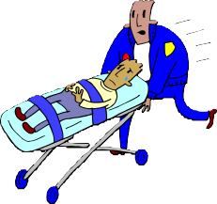 | MEDICAL AND INSURANCE  Medical and travel insurance is every participant’s responsibility.  PHARMACY  For those under any form of medication, please remember to bring your prescription medicines with you.
MEALS PROVIDED DURING THE WORKSHOP
Tea breaks and lunch will be provided during the conference. There are efforts to care for those with diet challenges.
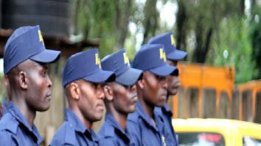 | SECURITY  Nairobi is a relatively peaceful city, and the Dimesse center is well secured. However, as in any location, participants are advised to take the standard safety precautions like:  - Keep a copy of identification with you;  - Do not walk alone outside the conference center ;  - You will need to identify yourself to the Dimesse security while entering the venue of the conference for security purposes
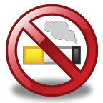 | SMOKING  The Dimesse Centre is entirely a no smoking Zone  However, if you have to smoke, ask for designated smoking areas, usually away from groups of people.
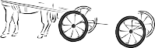 | TRANSPORT  In Nairobi, they drive on the left hand side as a traffic rule and so in case you will drive to the venue, please observe this rule. Also it is important to carry your driving permit. (There are taxi’s available outside the center)
THE PLANNING COMMITTEE FOR THE CONFERENCE WISHES YOU A SAFE TRIP TO AND FROM AND A PLEASANT STAY IN NAIROBI, KENYA

The first session begins at 4 PM at Dimesse the afternoon of the 6th June 2017..

